November 23rd, 2008
Hi
Well, I am back from Indonesia following a hectic 11 days. Quite a good visit. No problems with terrorists, nor with a 7.5 earthquake, which I did not feel as it was a long way away (over near Sulawesi, I think – see map).
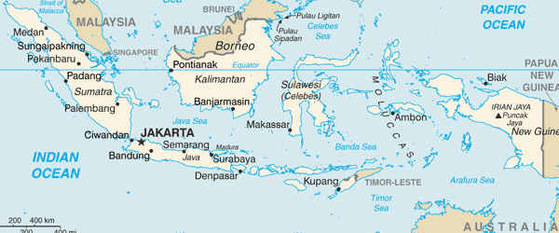
The map shows the places I visited – Singapore, Jakarta and Padang. I was also supposed to have visited Surabaya but this was cancelled. The last time I was in Indonesia, I visited Bandung.
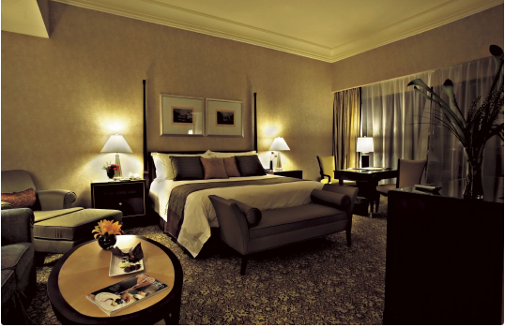
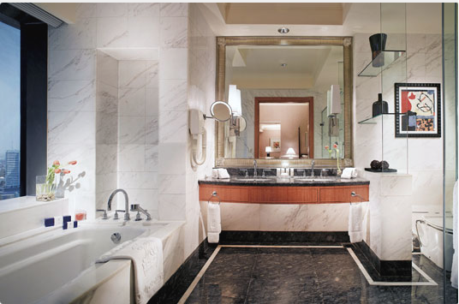
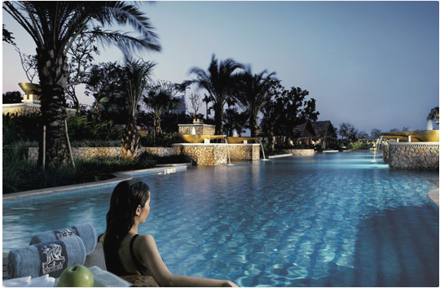
I left HK on the morning of Tuesday, November 11th for Singapore. On arrival, took a taxi to the Swissotel. I had a very poor room, on the second floor next to a busy street and very noisy. When sleeping I had to use earplugs, which I always carry with me for situations such as this. In the evening, met and had dinner with two people from the publisher. The next morning I went to the publisher’s offices to talk with various people. Then by taxi to the airport for the flight to Indonesia. Met at the airport and taken to the Ritz-Carlton hotel. This is the best hotel I have stayed in. Even though I had a basic room, it was still pretty posh as the photos below show.

During my one-week stay there I managed to fit in four swims (just 1 km each time) followed by a warm Jacuzzi each time. Jakarta itself is an appalling place. There is no easy way to get around, as there is no subway or efficient public transport system. It is not the place a tourist would rent a car, as even the locals cannot easily find there way around. One interesting thing about the roads is that, at certain times, they have carpool roads only. To get sufficient numbers for this, a driver will hire waifs who crowd the streets just for this purpose. While there, I did not venture out of the hotel even once; they had told me that at night it might be dangerous to do so, though I don’t think it is that bad.

[I will mention here an interesting fact about Indonesia that I and others got wrong. Indonesia is not an Islamic state; it is a secular country that has a predominantly Muslim population. Thus in the primary school primary books I will write, I will include little ‘mascot’ pictures of a boy and girl. I was thinking of having them in Islamic dress (as in the Brunei books) but this is not allowed; they must be in secular dress.]
Most days began very early, sometimes at 0530 or 0600. This is partly due to an unusual times zone in Jakarta where the Sun rises very early. For the first two days in Jakarta, I visited four local schools and taught some Grade 3 classes Science using English. This was mainly to find out their standard of English. And I must say it is pretty good; often much better than even secondary students in HK. The four schools covered a range of ability though they did not include the lowest ability level. The pupils’ English ability is often much better than that of their teachers. Two of the schools are Islamic primary schools, one where the pupils wore a secular uniform, the other where the girls were covered from head to toe. But they were not madrassas (?sp). Another school is a government school while the other is an international school. I must say I was most impressed with the pupils at the Islamic schools – very well behaved and very polite. At one, all the pupils welcomed and farewelled me with a handshake and a touch to their heads.
On Monday, November 17th, the workshops for the secondary schools were held at a convention centre. There was an opening session with the English, Science and Mathematics teachers together followed by separate subject sessions in the morning and afternoon. Tuesday was similar but for primary school teachers.
Wednesday morning was free so I had the last of my four swims. Checkout at 1 pm then to airport for the Garuda Indonesia flight to Padang (see map) in an old B737 which took about 90 minutes. The aircraft did not have seat videos, only the ceiling screens. For entertainment, they showed a “Just for laughs” video (a candid-camera type of thing), which I enjoyed a lot! (It’s funny how people can laugh at the misfortunes of others! If you were with me, given the way I laugh, you would probably be cringing and disowning me!!)
On Thursday, in Padang, there were the workshops for secondary teachers (none for primary). Unlike in Jakarta, these were arranged by the local Education Department and the organisation was terrible with many of my handouts missing, several subject groups in one large room rather than in separate rooms, people walking in and out. After my sessions, many teachers had photos taken with me. In the evening, we had a brief tour of the town and dinner at a beachside restaurant. This area of Indonesia is very Islamic and the majority of the women teachers were covered, in contrast to those in Jakarta.

On Friday, up again up 0530 with a quick breakfast and the return to Jakarta. Once there, had to wait several hours for the flight to Singapore. Had two lunches at the airport, the first with the publisher. Then I found that HSBC has a lounge and provides a free buffet for certain customers (which included me)! At Singapore, I took the late flight to HK. On arrival, I thought I had lost my passport. On going back to the plane to look for it, I found it in a part of my bag I almost never use. Got the midnight hotel bus back from the airport. On this one day, I ate an awful lot, having had six meals! (breakfast at hotel, three on aircraft and two at Jakarta airport).
Yesterday (Saturday) I got up at almost at noon but was still tired all day. Also, I was not hungry and ate very little. I had to go to the supermarket as I had almost no food. There was quite a lot of international Rugby too. The All Blacks beat Wales 29-9 in Cardiff. Also, in a big upset, the NZ Rugby League team beat Australia to become world champions for that version of the game. (Originally there was only one kind of Rugby, but then it split into Rugby Union – what you are familiar with – and Rugby League which is slightly different, e.g. with only 13 in a team.)

While in Jakarta, I saw on TV a BBC documentary that may interest you, particularly Gavin. I was about a 112-year-old WWI veteran, the last one still alive. Like many others, he said nothing about his wartime experiences until recently when he decided to remind people, especially school children, of what happened. Coincidentally, there was also an article about him in the “Jakarta Post” newspaper. Hi story is also in a book entitled Kitchener’s Last Volunteer. (Kitchener is best known for his famous recruitment posters at the time bearing his heavily moustachioed face and pointing hand to, 'Your country needs you'. He was Secretary of State for war at the beginning of WWI, organised armies on an unprecedented scale and became a symbol of the national will to win.)
That’s about it for now.

Cheers

